Homeostasis

What does the word homeostasis mean? ______________________________________________
_____________________________________________________________________________________________

Our bodies have to keep three important matters balanced, they are:
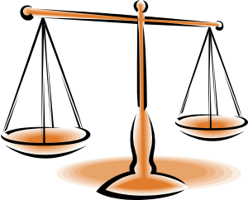
- ______________________________________
- ______________________________________
- ______________________________________

Too hot/ Too cold!
Explain what happens to your body when you get too hot: __________________________________________________________________________________________________________________________________________________ _________________________________________________________________________
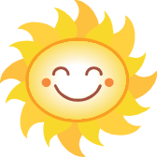
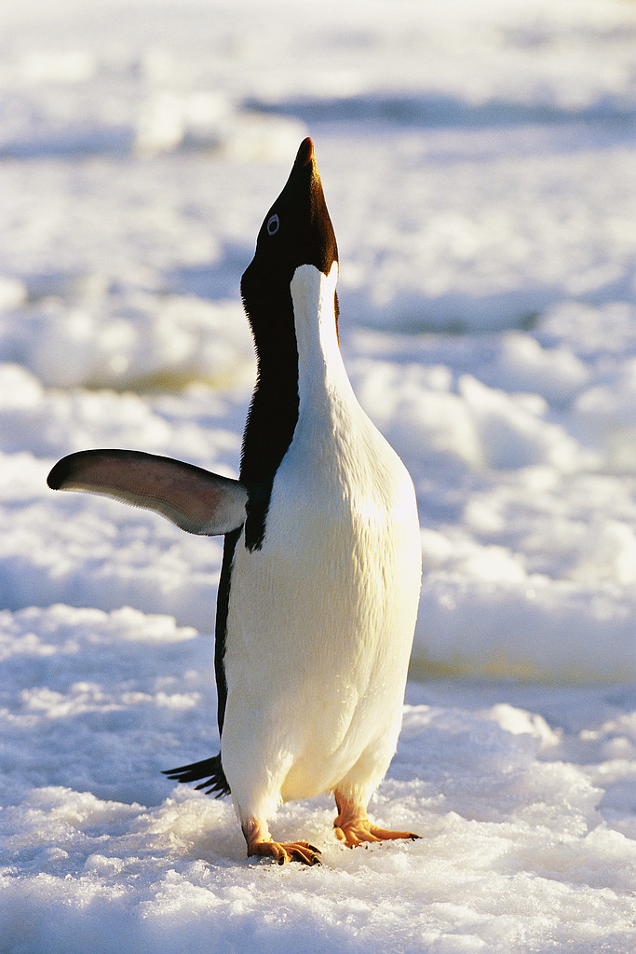
Explain what happens to your body when you get too cold: _________________________________________________________________________________________________________________________________________________________________________________________________________________________________

Fill in the gaps using the words: increase, decrease, 37

Too Hot
Sweating, hairs lie flat, and increased blood flow to the skin leads to a ___________ in temperature

_____________________
in temperature

Negative
feedback

Core temperature Core temperature
_______ ⁰C _______ ⁰C

_____________________
In temperature
Shivering, hairs stand on end and decreased blood flow to the skin leads to an ___________ in temperature

Too Cold
How can the core body temperature be measured?
__________________________________________________________________________________________________________________________________________________________________________________________

Very high and very low temperatures
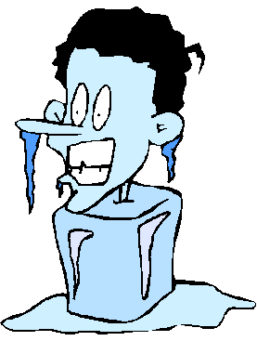
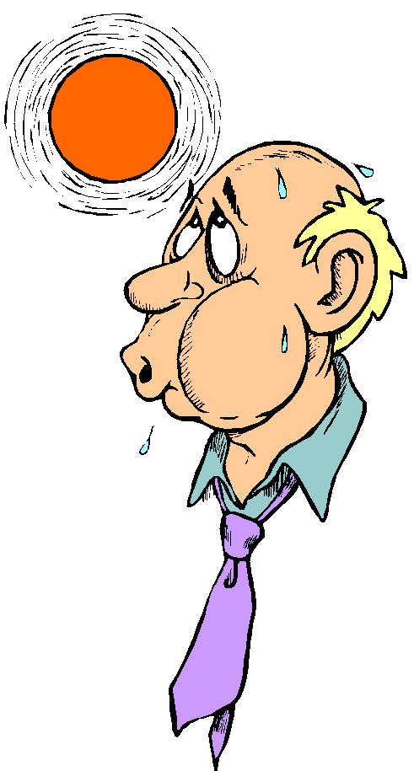

If you get too cold you can develop If you get too hot you can develop
_______________________________________ _______________________________________

Blood glucose levels
Inject sugar hormone diabetes blood pancreas food levels insulin

Some people suffer from a disease called d___________. They do not produce enough of a h____________ called i_____________ from the organ in the body called the p______________. Insulin controls the b____________ s___________ levels. Diabetics have to be careful that they do not eat too much sweet f__________. They may also need to i______________ themselves with the hormone insulin to help control there blood sugar l_________.

What is a hormone? ________________________________________________________________________________________________________________________________________________________________

Male and female sex hormones are responsible for secondary sexual characteristics
Male Hormone _______________________ | Female Hormone________________________

Homeostasis Bingo

Choose 9 words from below to fill in the boxes
Homeostasis Glucose Temperature Oestrogen

Testosterone Thermometer Diabetes 37⁰C

Hormone Shivering Sweating Balance

